# Optional: Using Tableau Desktop

In addition to accessing Tableau Public online, you can download a desktop version to create and upload data visualizations directly from your computer. Tableau Desktop is part of the Tableau Creator subscription, but you can start a free 14-day trial by downloading Tableau Desktop from their website. In order to access the desktop version, you will need a compatible device since Tableau Desktop doesn’t work on mobile devices or Chromebooks.

This reading will help you download Tableau Desktop, if you want to try it out.

I​mportant note: All hands-on activities are based on the use of Tableau Public. You don't need to download Tableau Desktop to complete the activities.

## Features

Tableau Public is a great free resource, and it allows you to explore a lot of data visualizations online. But the desktop version has features that can help make Tableau an even more powerful tool. Using Tableau Desktop you can:

* Interact with and combine data from more sources
* Save data visualizations locally to your device
* Keep your work more private and secure
* Build calculations and visualize them live in-platform
* Access built-in maps of over 50 countries
* Share your creations with specific users

The Tableau Creator subscription also gives you access to other useful tools, like Tableau Prep Builder, which can help you prepare your data for visualization and immediately use it.

## Downloading Tableau Desktop

You can start your free 14-day trial of Tableau Desktop by going to the [download page](https://www.tableau.com/products/trial).

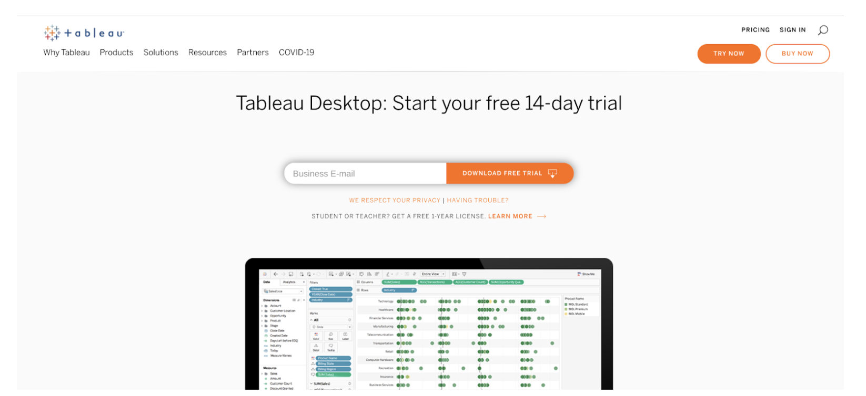

Click DOWNLOAD FREE TRIAL to get started. This will bring up a dialogue box prompting you to save the trial version to your desktop.

Once you have downloaded Tableau onto your desktop, you can go to the Connect menu to upload data from local files, like Excel spreadsheets or PDFs, connect to data stored in a server, or connect to data sources you have used before. Tableau also has a [step-by-step guide](https://help.tableau.com/current/guides/get-started-tutorial/en-us/get-started-tutorial-connect.htm) to help you get started using your own data in Tableau Desktop.

Tableau is a powerful tool, and once you have downloaded the app onto your desktop, you can start using it to create data visualizations of your own.